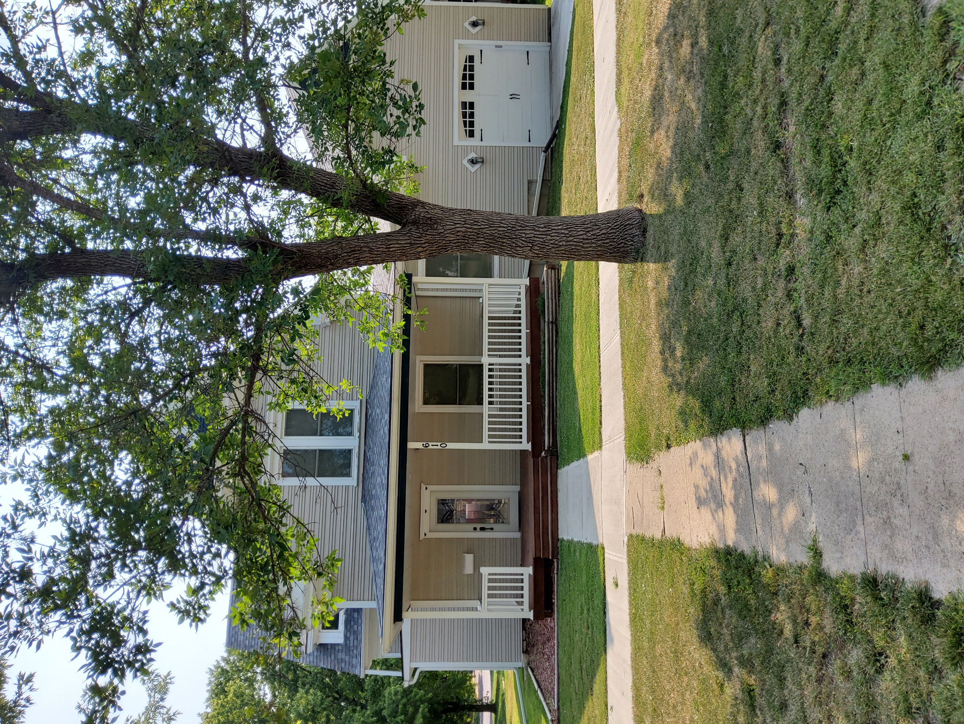
Donald Prell Realty & Auction LLC.
706 Broadway
Marysville KS 66508

Address____610 N 11th____

Asking Price: $__$249,00_______________
# Of Bedrooms | 4 bedrooms
# of Bathrooms | 2 bathrooms
Square Footage | 2,137 square feet
Year Built | 1915
Property Tax | 4467.73
Co. Tax Appraisal $ | 223,340

Type of A/C__ central _____________________
Type of Heat__ __ _forced____________________
Type of Water Heater__ gas____ _____________________
Floor Covering
X | Carpet
X | Tile
X | Hardwood
 | Linoleum

NOTES

Remodeled from top to bottom.
Roof
 | Metal
X | Shingle
 | Slate
 | Tile
 | Other

Exterior
 | Brick
 | Concrete
 | Metal
 | Shingle
 | Stucco
 | Vinyl
 | Wood
X | Other

Parking
 | Carport
1 | Garage Attached
 | Garage detached
 | Off Street
X | On Street

Indoor Features
X | Attic
X | Ceiling Fans
X | Double Pane Windows
 | Fireplace
 | Intercom System
X | Jetted tub
 | Security System
 | Skylights
X | Vaulted Ceiling

Architectural Style
 | Bungalow
 | Colonial
 | Contemporary
 | Loft
X | Victorian
 | Ranch
 | Split-Level
 | Other

Outdoor Amenities
X | Porch
 | Barbecue Area
X | Deck
 | Fenced Yard
 | Pool
 | Sprinkler System

Basement
 | Finished
X | Unfinished
 | Partially Finished
 | None
 | Crawl Space
 | Strom shelter

Appliances
X | Dishwasher
 | Dryer
 | Freezer
X | Garbage Disposal
X | Microwave
X | Range/Oven
X | Refrigerator
 | Trash Compactor
 | Washer

Rooms
 | Breakfast Nook
 | Dining Room
 | Family Room
 | Laundry Room
X | Master Bath
 | Mud Room
X | Office
 | Pantry
 | Walk-in Closet

