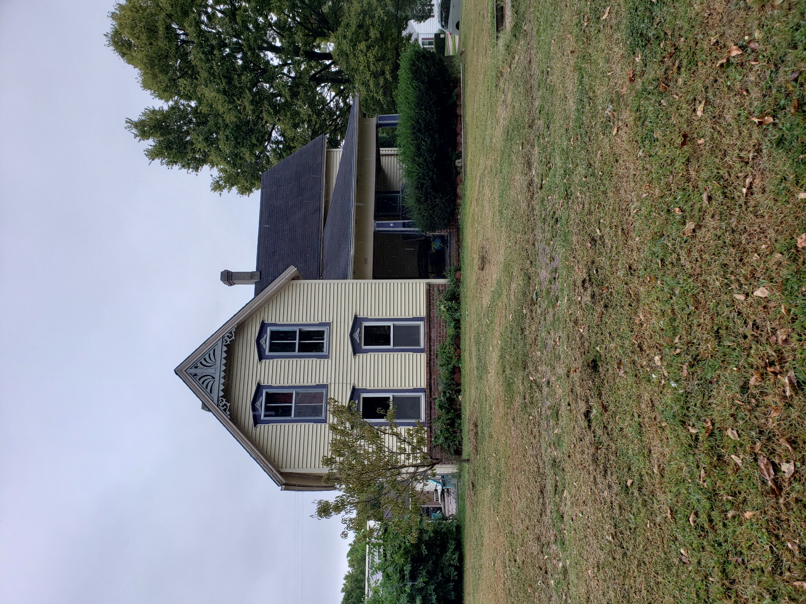
Donald Prell Realty & Auction LLC.
706 Broadway
Marysville KS 66508

Address_1401 Elm St. Marysville KS________

Asking Price: $__81,000_______________
# Of Bedrooms | 4
# of Bathrooms | 2
Square Footage | 1618
Year Built | 1880
Property Tax | 1416.
Co. Tax Appraisal $ | 71,150

Type of A/C_Central 2020 _____________________
Type of Heat__Forced __ _____________________
Type of Water Heater__Gas ____ _____________________
Floor Covering
x | Carpet
x | Tile
x | Hardwood
x | Linoleum

NOTES

Roof
 | Metal
x | Shingle
 | Slate
 | Tile
 | Other

Exterior
 | Brick
 | Concrete
 | Metal
 | Shingle
 | Stucco
x | Vinyl
 | Wood
 | Other

Parking
 | Carport
 | Garage Attached
2 | Garage detached
 | Off Street
 | On Street

Indoor Features
 | Attic
 | Ceiling Fans
 | Double Pane Windows
 | Fireplace
 | Intercom System
x | Jetted tub
 | Security System
 | Skylights
 | Vaulted Ceiling

Architectural Style
x | Bungalow
 | Colonial
 | Contemporary
 | Loft
 | Victorian
 | Ranch
 | Split-Level
 | Other

Outdoor Amenities
x | Porch
 | Barbecue Area
x | Deck
x | Fenced Yard
 | Pool
 | Sprinkler System

Basement
 | Finished
x | Unfinished
 | Partially Finished
 | None
x | Crawl Space
 | Strom shelter

Appliances
x | Dishwasher
 | Dryer
 | Freezer
 | Garbage Disposal
x | Microwave
x | Range/Oven
x | Refrigerator
 | Trash Compactor
 | Washer

Rooms
 | Breakfast Nook
x | Dining Room
 | Family Room
 | Laundry Room
 | Master Bath
 | Mud Room
 | Office
 | Pantry
 | Walk-in Closet

