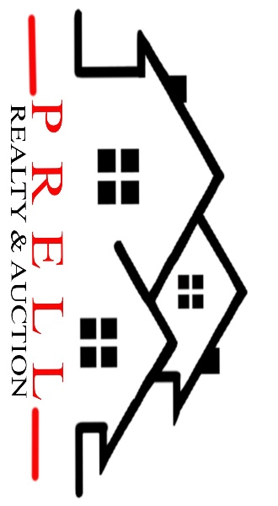
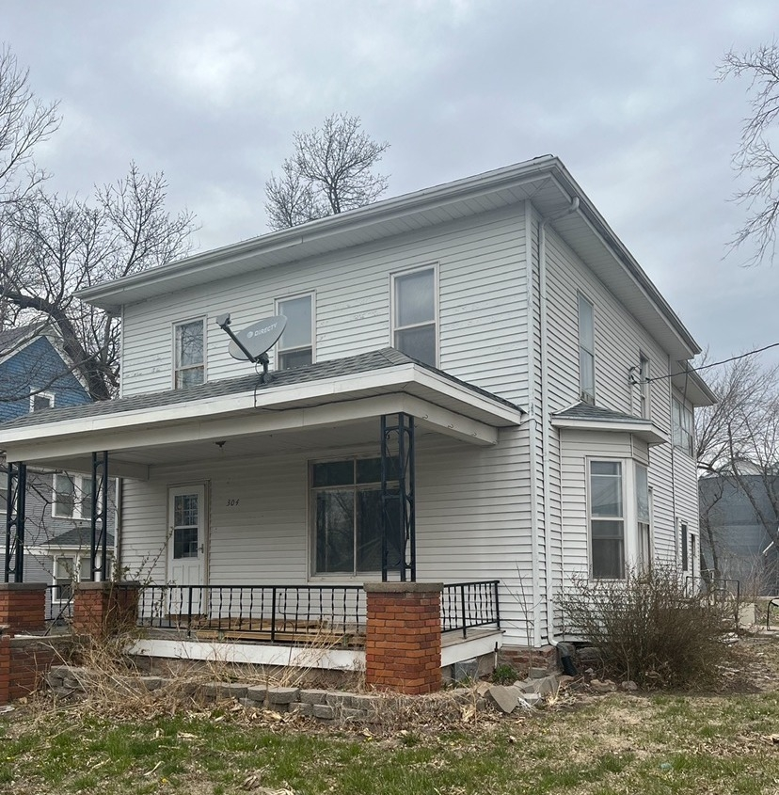
1042 Pony Express Hwy, Marysville KS 66508

Address_304 Maple, Axtell KS 66403________

Asking Price: $_125,000________________
# Of Bedrooms | 3-4
# of Bathrooms | 2
Square Footage | 1968
Year Built | 1890
Property Tax | 640.00
Co. Tax Appraisal $ | 44,050

Type of A/C__Central _____________________
Type of Heat__forced __ _____________________
Type of Water Heater_Gas_ ____ _____________________
Floor Covering
X | Carpet
X | Tile
X | Hardwood
 | Linoleum

NOTES

Roof
 | Metal
X | Shingle
 | Slate
 | Tile
 | Other

Exterior
 | Brick
 | Concrete
 | Metal
 | Shingle
 | Stucco
X | Vinyl
 | Wood
 | Other

Parking
 | Carport
 | Garage Attached
 | Garage detached
X | Off Street
 | On Street

Indoor Features
X | Attic
X | Ceiling Fans
X | Double Pane Windows
 | Fireplace
 | Intercom System
 | Jetted tub
 | Security System
 | Skylights
 | Vaulted Ceiling

Architectural Style
X | Bungalow
 | Colonial
 | Contemporary
 | Loft
 | Victorian
 | Ranch
 | Split-Level
 | Other

Outdoor Amenities
X | Porch
 | Barbecue Area
 | Deck
 | Fenced Yard
 | Pool
 | Sprinkler System

Basement
 | Finished
X | Unfinished
 | Partially Finished
 | None
 | Crawl Space
 | Strom shelter

Appliances
X | Dishwasher
X | Dryer
 | Freezer
X | Garbage Disposal
 | Microwave
X | Range/Oven
X | Refrigerator
 | Trash Compactor
X | Washer

Rooms
 | Breakfast Nook
X | Dining Room
 | Family Room
X | Laundry Room
 | Master Bath
X | Mud Room
 | Office
X | Pantry
 | Walk-in Closet

