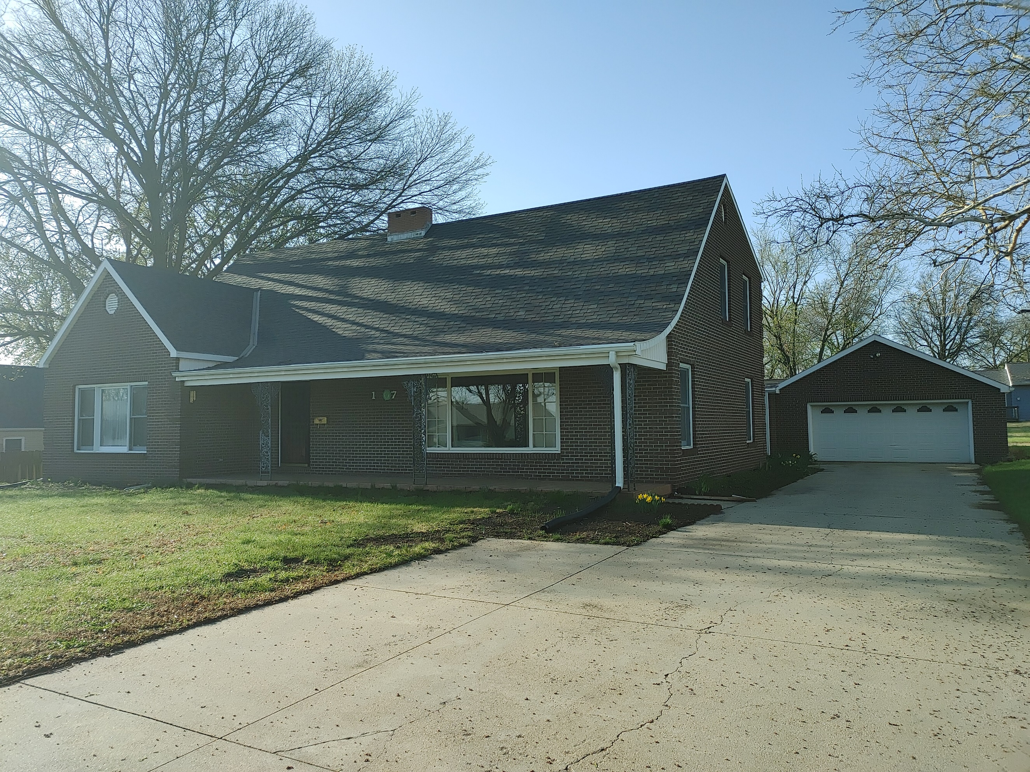
Donald Prell Realty & Auction LLC.
706 Broadway
Marysville KS 66508

Address_1907 Jenkins Marysille, KS________

Asking Price: $_265,000________________
# Of Bedrooms | 4 + 3 non-conforming
# of Bathrooms | 3
Square Footage | 3994 House / Lot 13200
Year Built | 1959
Property Tax | 4347
Co. Tax Appraisal $ | 238,600

Type of A/C__Central _____________________
Type of Heat__gas central __ _____________________
Type of Water Heater_Gas 2020_ ____ _____________________
Floor Covering
X | Carpet
 | Tile
X | Hardwood
X | Linoleum

NOTES

Roof
Metal
Shingle
Slate
Tile
Other

Exterior
Brick
Concrete
Metal
Shingle
Stucco
Vinyl
Wood
Other

Parking
 | Carport
1 | Garage Attached
 | Garage detached
 | Off Street
 | On Street

Indoor Features
X | Attic
X | Ceiling Fans
X | Double Pane Windows
X | Fireplace
 | Intercom System
X | Jetted tub
 | Security System
 | Skylights
X | Vaulted Ceiling

Architectural Style
 | Bungalow
 | Colonial
 | Contemporary
 | Loft
 | Victorian
 | Ranch
 | Split-Level
X | Other

Outdoor Amenities
X | Porch
 | Barbecue Area
 | Deck
 | Fenced Yard
 | Pool
 | Sprinkler System

Basement
X | Finished
 | Unfinished
 | Partially Finished
 | None
 | Crawl Space
 | Strom shelter

Appliances
X | Dishwasher
 | Dryer
 | Freezer
X | Garbage Disposal
 | Microwave
X | Range/Oven
X | Refrigerator
 | Trash Compactor
 | Washer

Rooms
X | Breakfast Nook
X | Dining Room
X | Family Room
X | Laundry Room
 | Master Bath
X | Mud Room
X | Office
 | Pantry
X | Walk-in Closet

