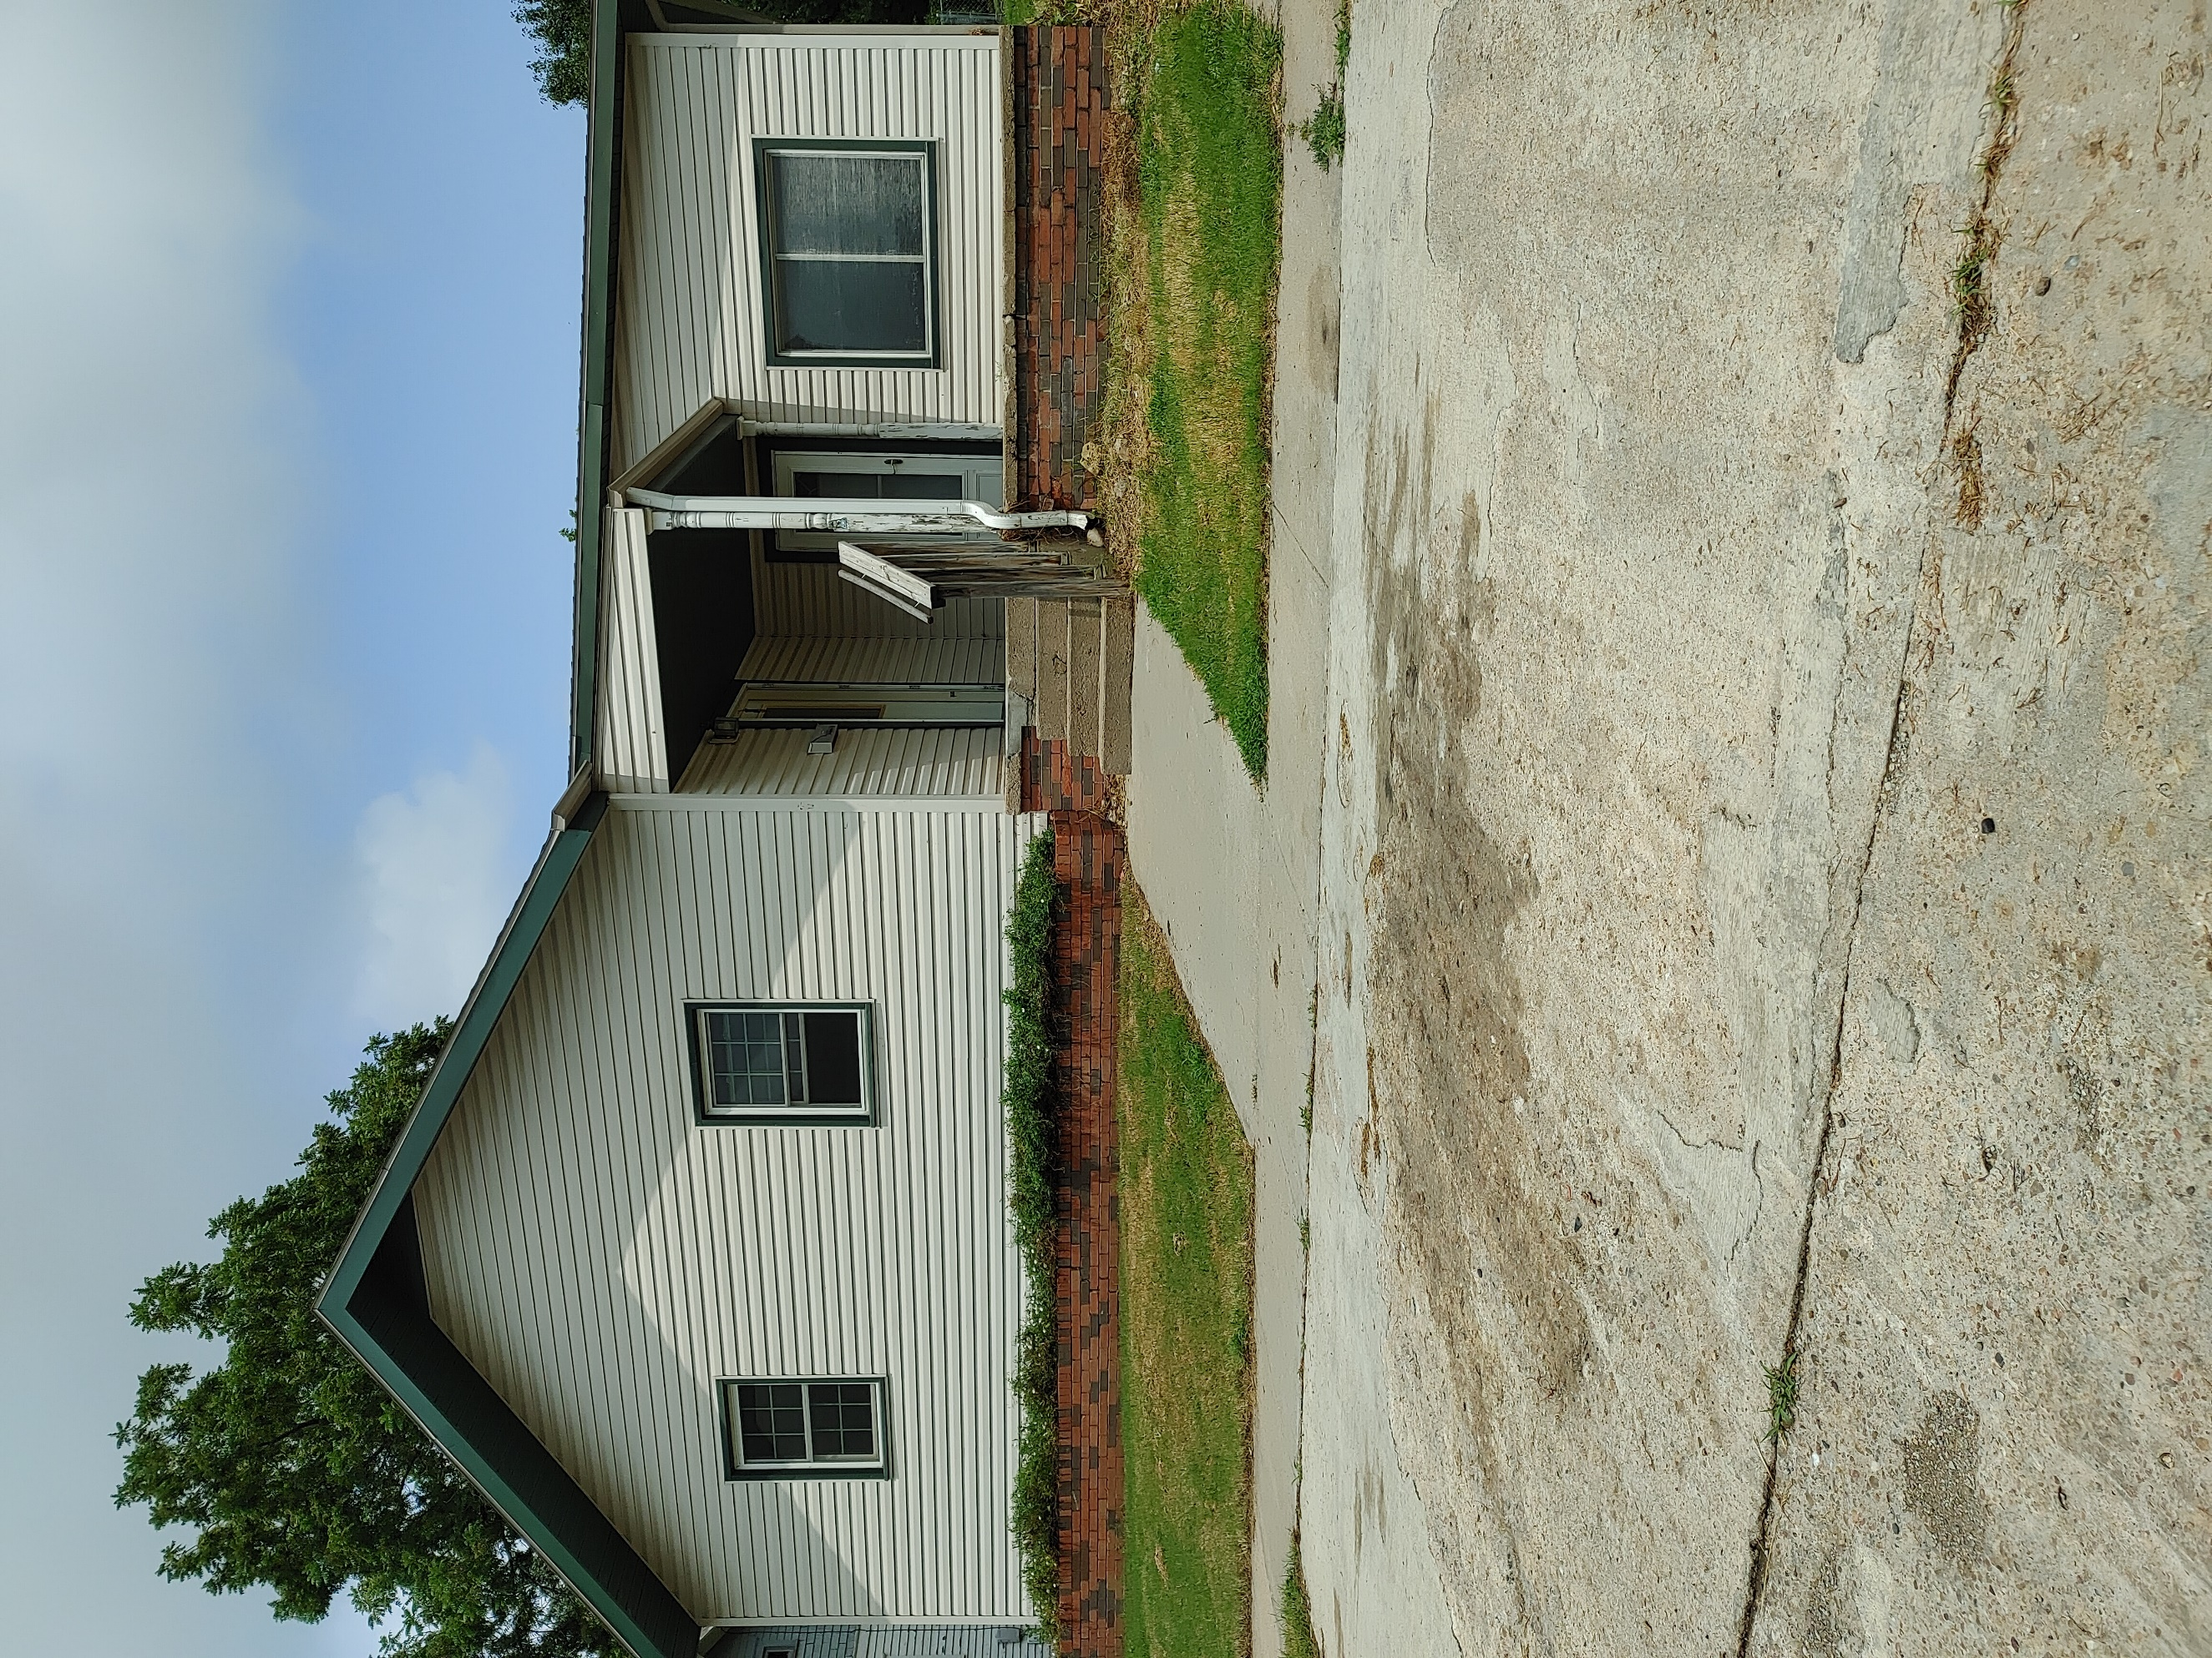
Donald Prell Realty & Auction LLC.
706 Broadway
Marysville KS 66508

Address_1204 Laramie Marysville KS________

Asking Price: $_95,000________________
# Of Bedrooms | 4
# of Bathrooms | 1
Square Footage | 1848
Year Built | 1935
Property Tax | 1170.00
Co. Tax Appraisal $ | 60,000

Type of A/C__ _____________________
Type of Heat__ __ _____________________
Type of Water Heater__ ____ _____________________
Floor Covering
X | Carpet
 | Tile
 | Hardwood
X | Linoleum

NOTES

Roof
 | Metal
X | Shingle
 | Slate
 | Tile
 | Other

Exterior
 | Brick
 | Concrete
 | Metal
 | Shingle
 | Stucco
X | Vinyl
 | Wood
 | Other

Parking
 | Carport
 | Garage Attached
 | Garage detached
 | Off Street
X | On Street

Indoor Features
 | Attic
X | Ceiling Fans
 | Double Pane Windows
 | Fireplace
 | Intercom System
 | Jetted tub
 | Security System
 | Skylights
 | Vaulted Ceiling

Architectural Style
 | Bungalow
 | Colonial
 | Contemporary
 | Loft
 | Victorian
 | Ranch
 | Split-Level
X | Other

Outdoor Amenities
X | Porch
 | Barbecue Area
 | Deck
 | Fenced Yard
 | Pool
 | Sprinkler System

Basement
 | Finished
X | Unfinished
 | Partially Finished
 | None
 | Crawl Space
 | Strom shelter

Appliances
Dishwasher
Dryer
Freezer
Garbage Disposal
Microwave
Range/Oven
Refrigerator
Trash Compactor
Washer

Rooms
X | Breakfast Nook
X | Dining Room
X | Family Room
X | Laundry Room
 | Master Bath
 | Mud Room
 | Office
 | Pantry
 | Walk-in Closet

