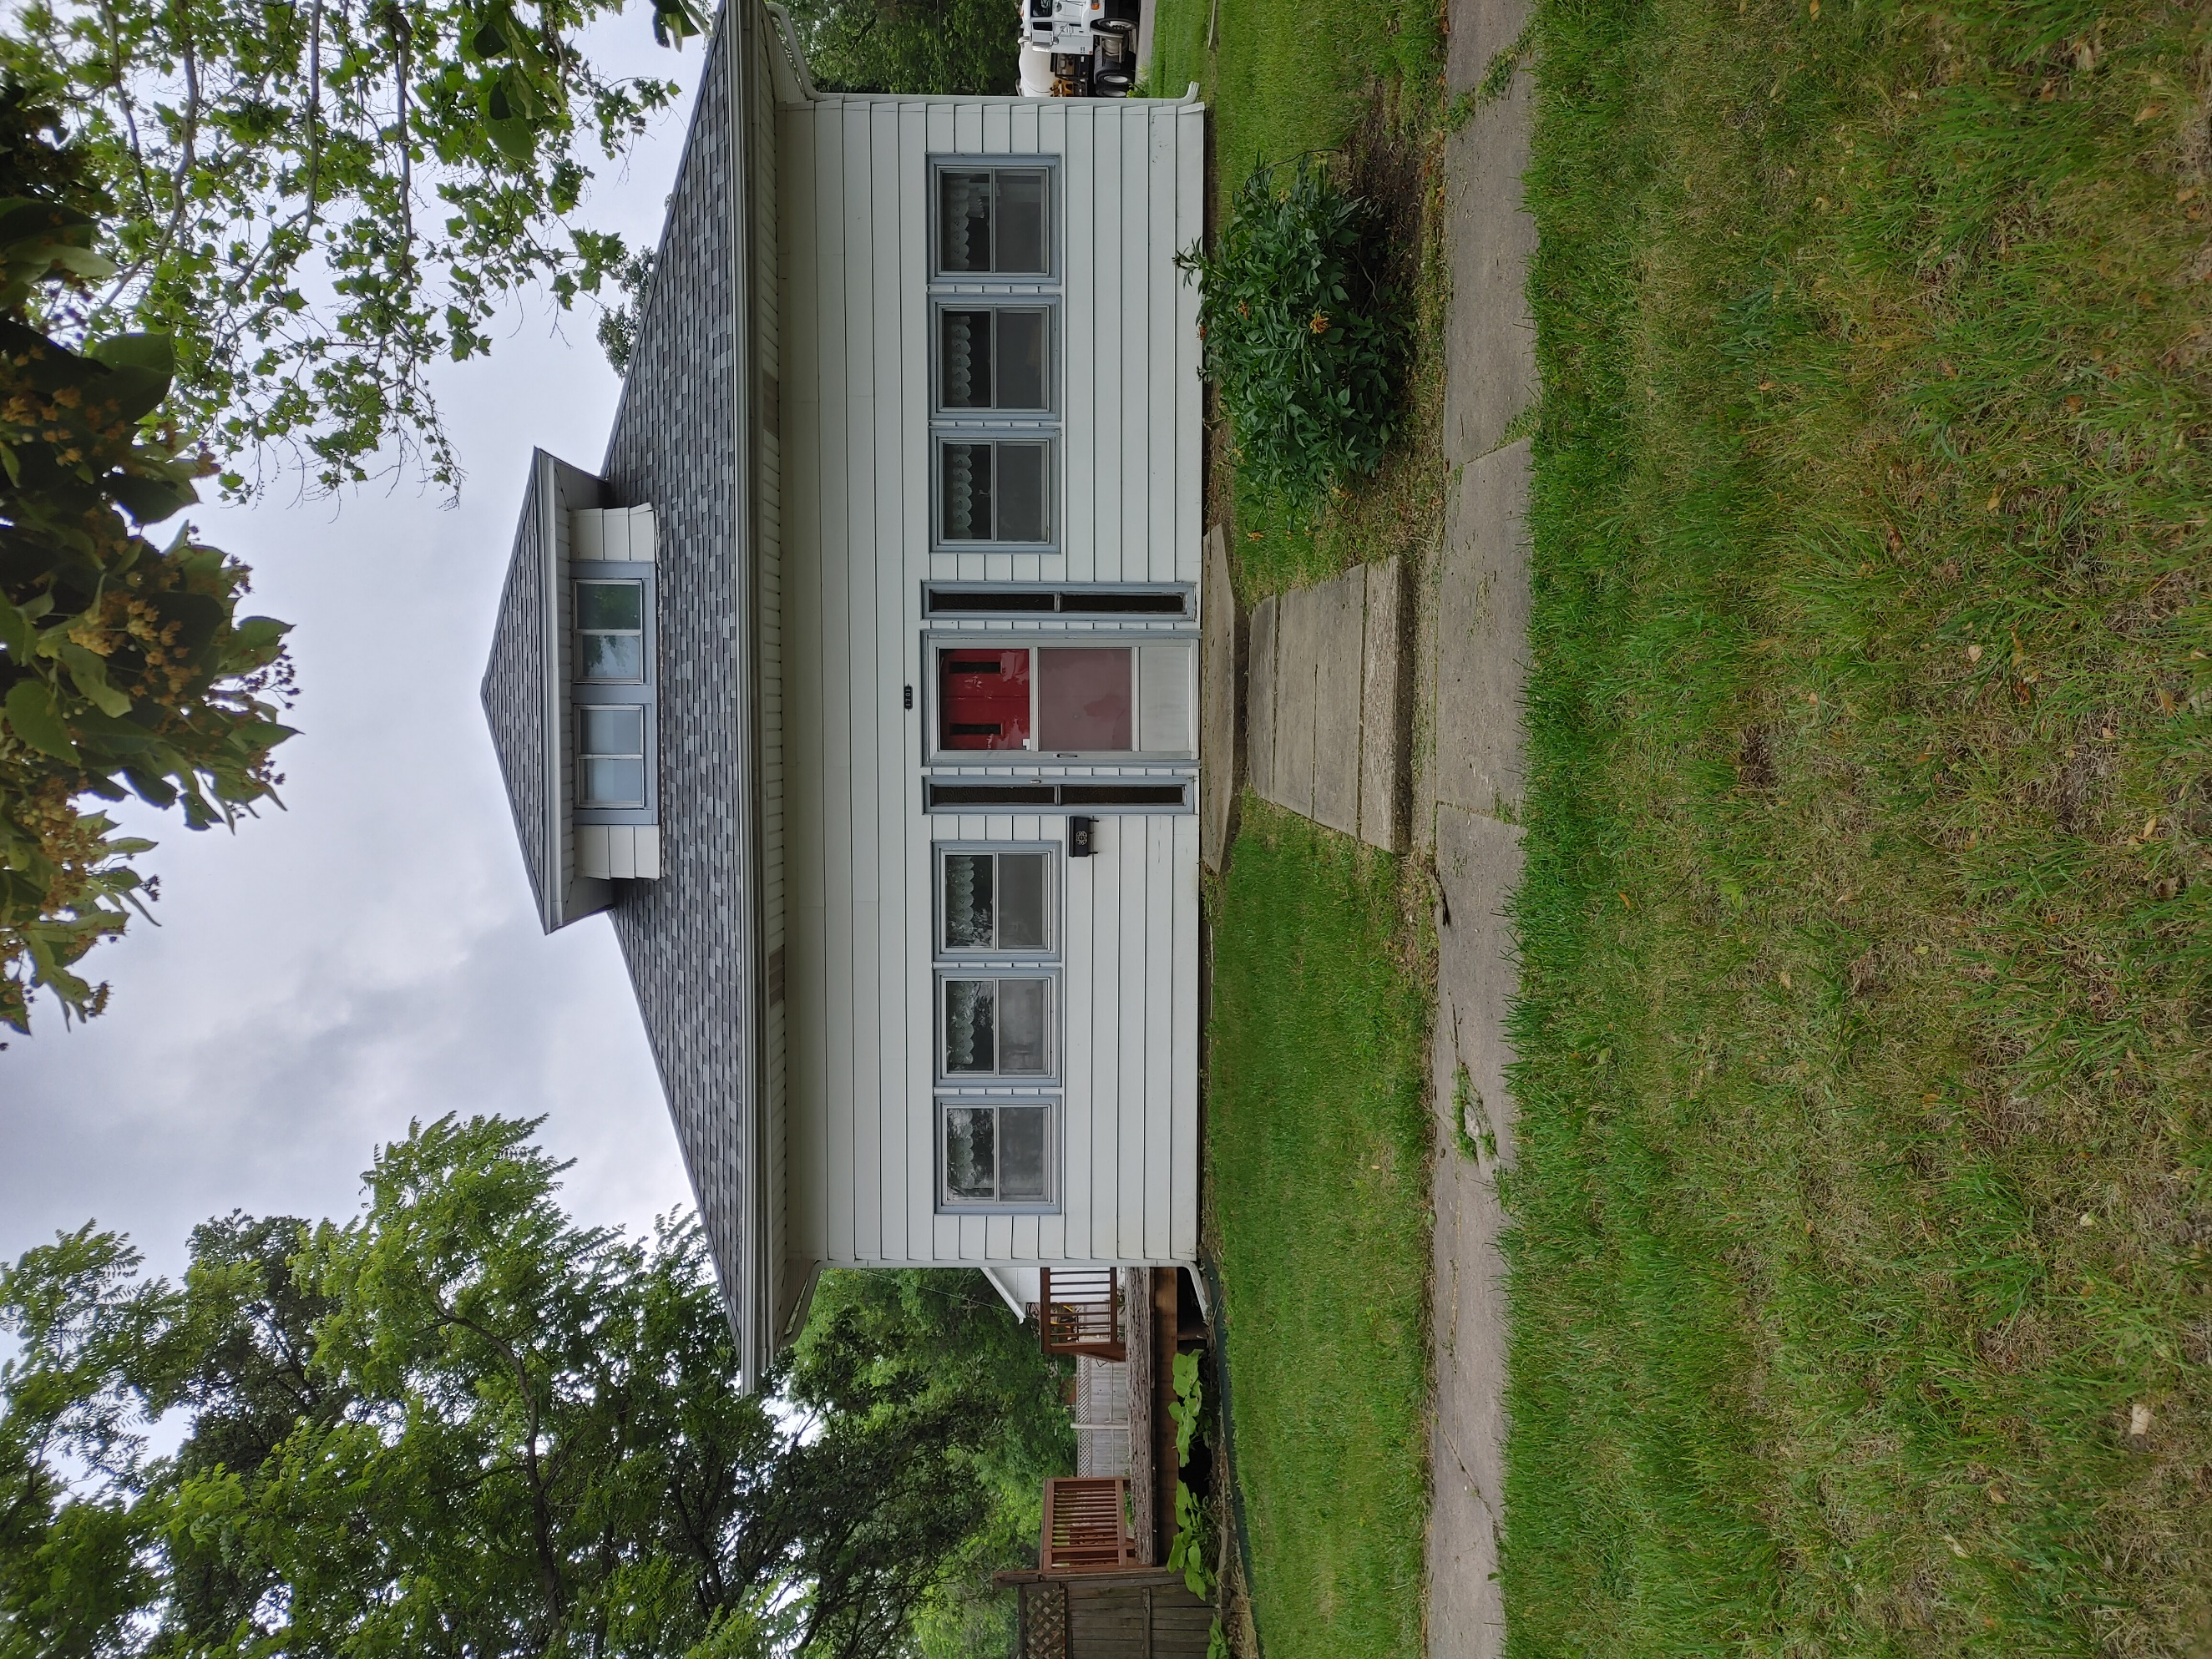
Donald Prell Realty & Auction LLC.
706 Broadway
Marysville KS 66508

Address_1701 May Marysville KS 66508__

Asking Price: $__120,000____________
# Of Bedrooms | 3 +
# of Bathrooms | 2
Square Footage | 1649
Year Built | 1924
Property Tax | 1915.00
Co. Tax Appraisal $ | 99,730

Type of A/C_Central_ _____________________
Type of Heat__Forced __ _____________________
Type of Water Heater__ Gas____ _____________________
Floor Covering
X | Carpet
 | Tile
 | Hardwood
X | Linoleum

NOTES

Roof
 | Metal
X | Shingle
 | Slate
 | Tile
 | Other

Exterior
 | Brick
 | Concrete
 | Metal
 | Shingle
 | Stucco
X | Vinyl
 | Wood
 | Other

Parking
 | Carport
 | Garage Attached
3 | Garage detached
 | Off Street
 | On Street

Indoor Features
 | Attic
X | Ceiling Fans
 | Double Pane Windows
 | Fireplace
 | Intercom System
 | Jetted tub
 | Security System
 | Skylights
 | Vaulted Ceiling

Architectural Style
 | Bungalow
 | Colonial
 | Contemporary
 | Loft
 | Victorian
 | Ranch
 | Split-Level
X | Other

Outdoor Amenities
 | Porch
 | Barbecue Area
X | Deck
X | Fenced Yard
 | Pool
 | Sprinkler System

Basement
 | Finished
 | Unfinished
X | Partially Finished
 | None
 | Crawl Space
 | Strom shelter

Appliances
X | Dishwasher
 | Dryer
 | Freezer
 | Garbage Disposal
 | Microwave
X | Range/Oven
 | Refrigerator
 | Trash Compactor
 | Washer

Rooms
 | Breakfast Nook
X | Dining Room
 | Family Room
X | Laundry Room
 | Master Bath
 | Mud Room
 | Office
 | Pantry
 | Walk-in Closet

