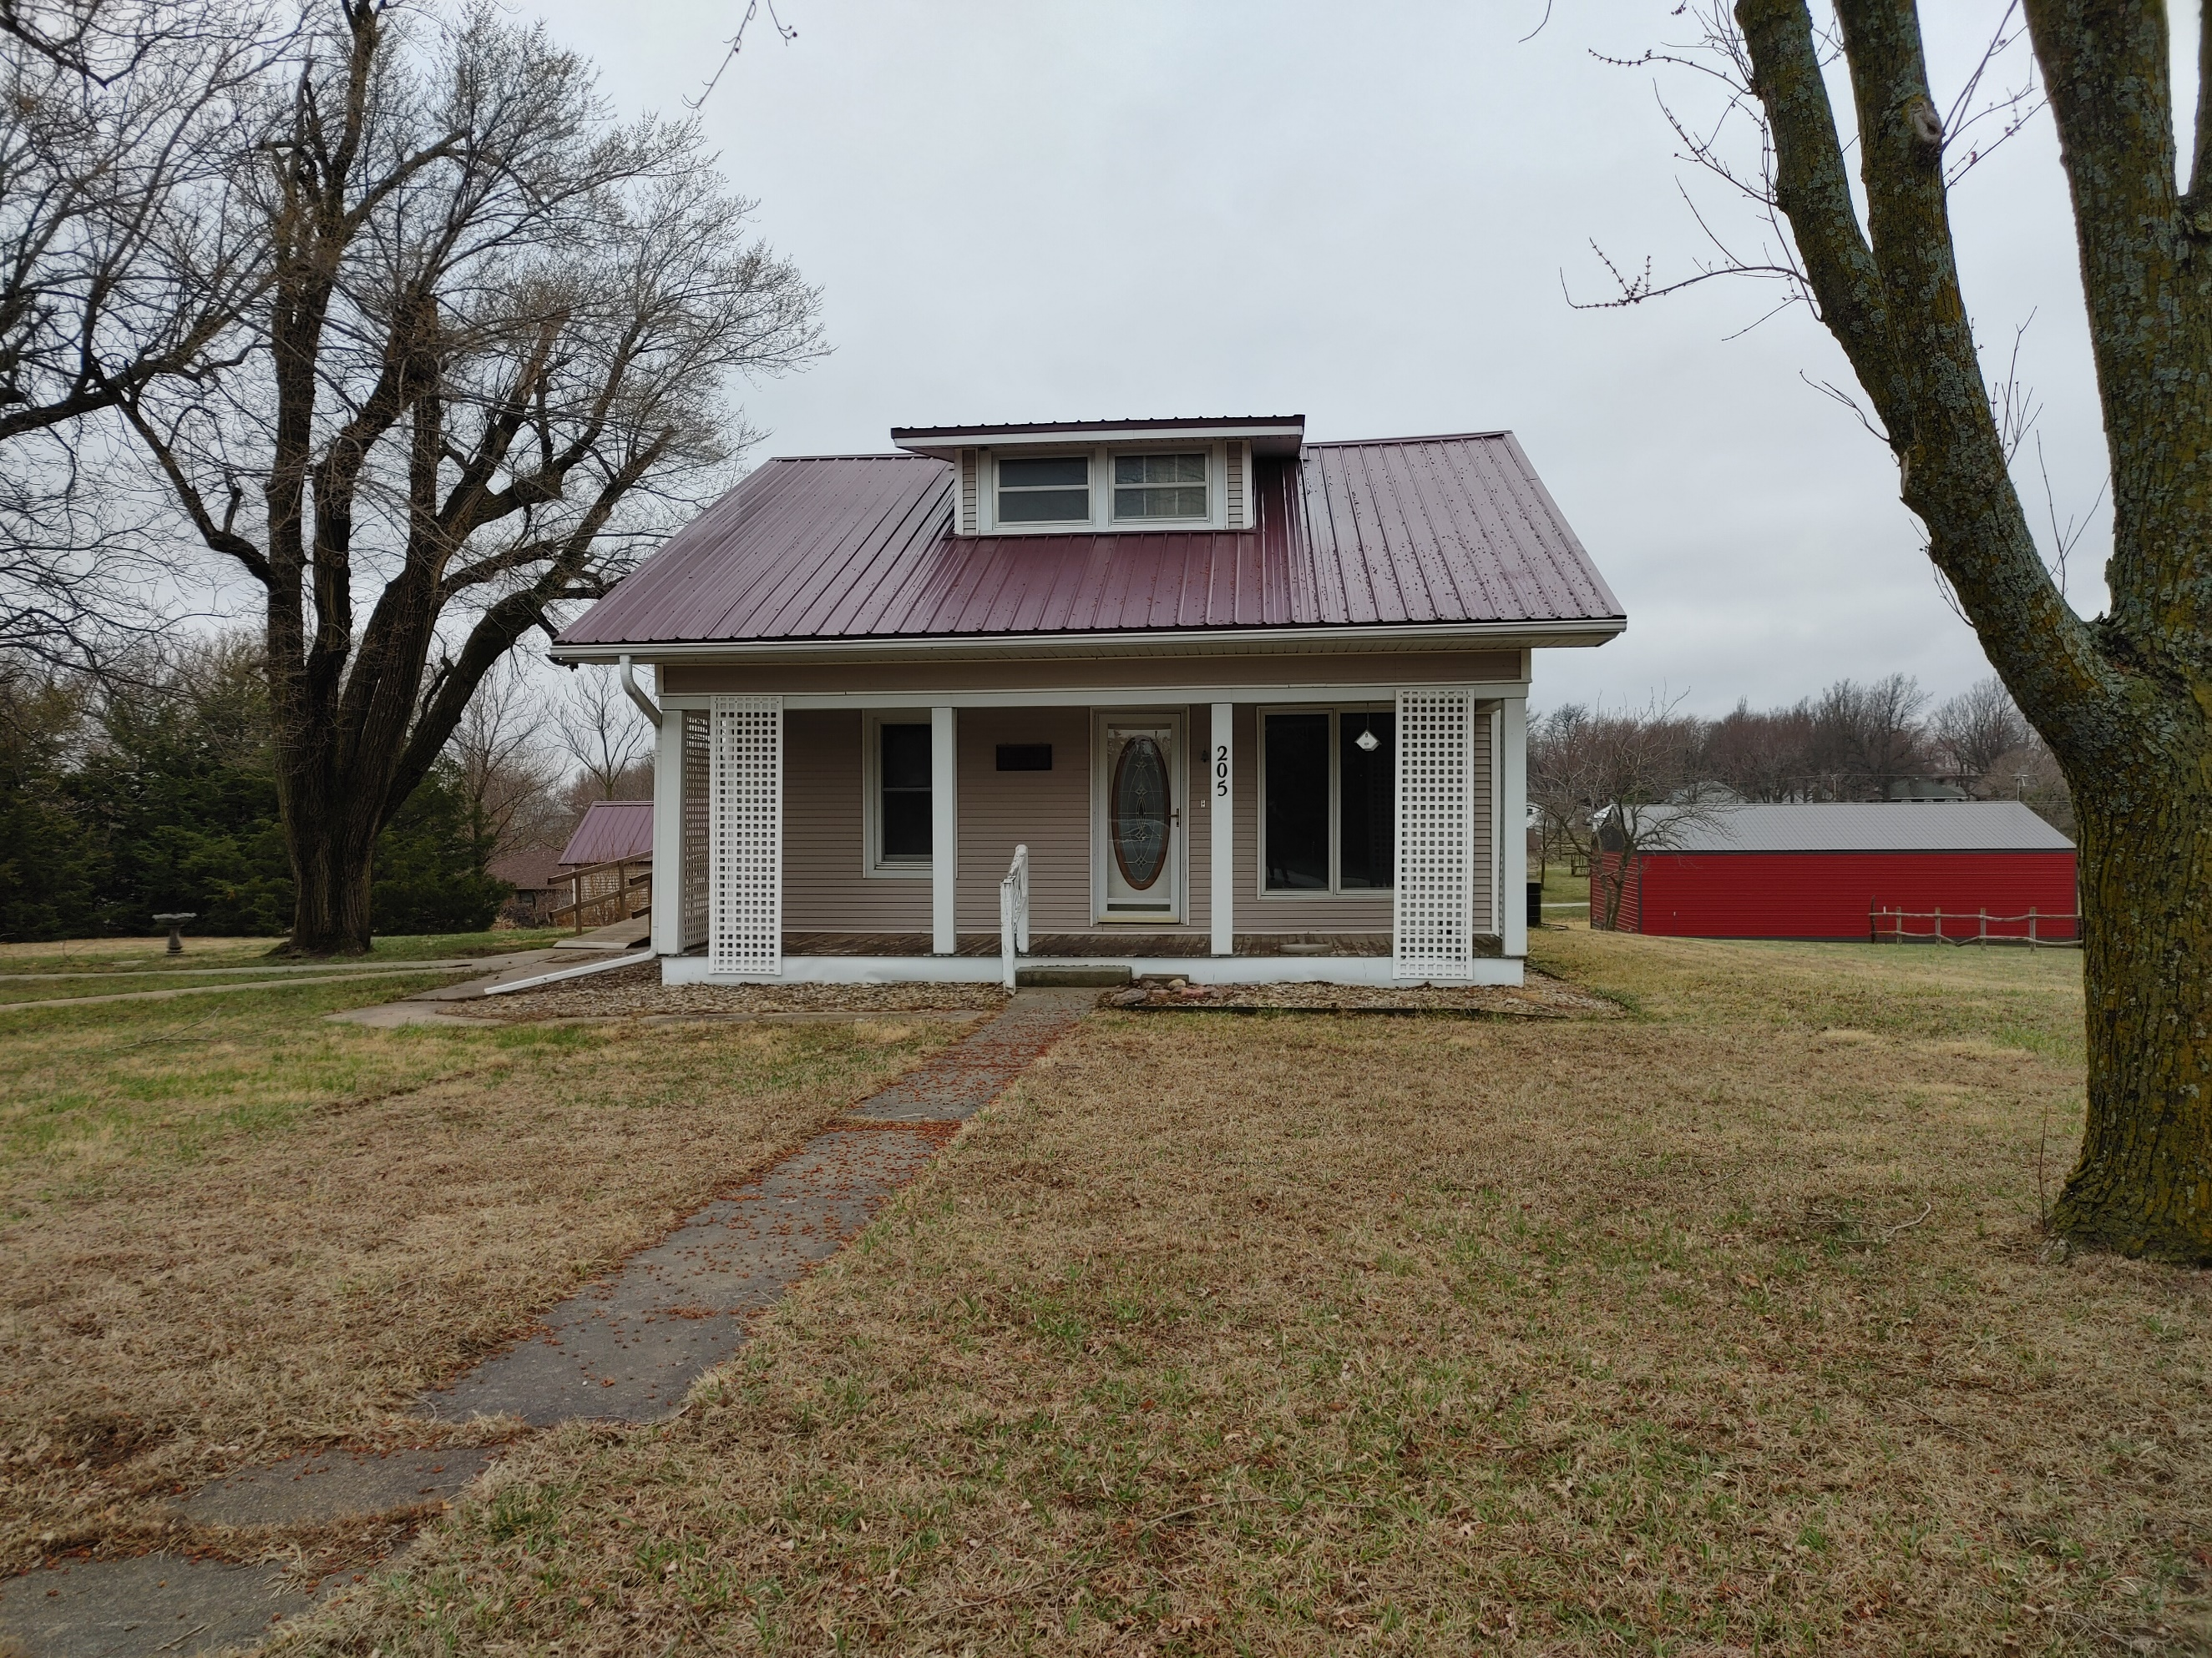
Donald Prell Realty & Auction LLC.
706 Broadway
Marysville KS 66508

Address_205 S 8th, Axtell KS________

Asking Price: $_89,900________________
# Of Bedrooms | 2-3
# of Bathrooms | 1
Square Footage | 1008
Year Built | 1923
Property Tax | 864.86
Co. Tax Appraisal $ | 51,210

Type of A/C__ _____________________
Type of Heat__ __ _____________________
Type of Water Heater__GAS New in 2021 ____ _____________________
Floor Covering
x | Carpet
 | Tile
 | Hardwood
 | Linoleum

NOTES

Roof
x | Metal
 | Shingle
 | Slate
 | Tile
 | Other

Exterior
 | Brick
 | Concrete
x | Metal
 | Shingle
 | Stucco
 | Vinyl
 | Wood
 | Other

Parking
 | Carport
 | Garage Attached
2 | Garage detached
 | Off Street
 | On Street

Indoor Features
x | Attic
x | Ceiling Fans
 | Double Pane Windows
 | Fireplace
 | Intercom System
 | Jetted tub
 | Security System
 | Skylights
 | Vaulted Ceiling

Architectural Style
 | Bungalow
 | Colonial
 | Contemporary
 | Loft
 | Victorian
x | Ranch
 | Split-Level
 | Other

Outdoor Amenities
x | Porch
 | Barbecue Area
 | Deck
 | Fenced Yard
 | Pool
 | Sprinkler System

Basement
Finished
Unfinished
Partially Finished
None
Crawl Space
Strom shelter

Appliances
x | Dishwasher
 | Dryer
 | Freezer
 | Garbage Disposal
 | Microwave
x | Range/Oven
x | Refrigerator
 | Trash Compactor
 | Washer

Rooms
 | Breakfast Nook
x | Dining Room
 | Family Room
 | Laundry Room
 | Master Bath
 | Mud Room
 | Office
 | Pantry
 | Walk-in Closet

